**Abstract****3**

**Problem Statement****3**

Business Background 3

Needs 3

Objectives 4

**Requirements****4**

User Requirement 4

Glossary of Relevant Domain Terminology 4

User Groups 4

Functional Requirements 4

Project Scope 4

User Scenarios 6

List of User Functional Requirements 14

4.1.4. Non-functional Requirements 18

4.1.4.1. Product: Performance Requirements 18

4.1.4.2. Product: Dependability/Reliability/Security 18

4.1.4.3. Organizational: Development Requirements 19

**System Requirements** **19**

Functional Requirements 19

List of System Functional Requirements 19

System Behavior 28

Data Requirements 36

4.2.2. Non-functional Requirements 37

4.2.2.1. Product: Performance Requirements 37

4.2.2.2. Product: Dependability/Reliability/Security 38

4.2.2.3. Organizational: Development Requirements 38

**Requirements Trace Table** **39**

**Exploratory Studies** **40**

Relevant Techniques 40

Relevant Packages/Products 40

Broader Impacts 40

**System Design** **40**

Architectural Design 40

**System Implementation** **40**

Programming Languages & Tools 40

Coding Conventions 40

Code Version Control 40

**Challenges & Open Issues**41

Challenges Faced in Requirements Engineering 41

**System Manuals****41**

Instructions for System Development 41

How to setup the development environment 41

Notes on system further extension 41

**12. References****42**

# Abstract

**IBM wants to use “natural language processing and machine learning to reveal insights from large amounts of unstructured data.” (**[**http://www.ibm.com/watson/what-is-watson.html**](http://www.ibm.com/watson/what-is-watson.html)**) IBM Watson is the technology that IBM uses to achieve this goal.**

**Our project seeks to help guide first year students and their advisors by using their questions about the CSSE majors at Behrend as input and providing a structured analysis of possible academic careers built from Watson’s insights.**

**We will increase Watson’s domain to include insight related to the CSSE majors at Penn State Behrend. This will reveal more insights about majors in Penn State Behrend for Watson, achieving a small portion of IBM’s goal. In addition, this will assist advisors with giving advice to new students to Penn State Behrend as well as being able to answer some questions for students without them having to go hunting for information.**

**In this report, we breakdown our goals into user and system requirements showing the engineering process of this project. UML Diagrams are also provided for further detail and explanation of this process.**

# Problem Statement

## Business Background

**IBM Watson’s services, including Bluemix's APIs and other services from 3rd parties or developers, can be utilized to conduct textual analysis and output a numerical scale of performance factor. Web Experience Management (WEM) can be trained to answer many open-ended questions. The question we are trying to answer is whether we can create a system to assist with the enrollment process, through use of Bluemix and WEM.**

## Needs

**To increase the effectiveness of the IBM Watson services, a larger domain is needed. Additionally, students are often unsure of which fields would coincide with their interests and talents.**

## Objectives

**The objective of this project is to increase Watson’s domain to include Penn State Behrend’s academic information related to the CSSE majors, such as recommended courses, FAQs, and advisor information. The project will enable students to make a better decision as to which careers they might be interested in pursuing and what each path would entail. It will also help advisors to accurately guide the students.**

# Requirements

## User Requirement

### Glossary of Relevant Domain Terminology

* + - 1. **Watson - An IBM supercomputer that combines artificial intelligence (AI) and sophisticated analytical software for optimal performance as a “question answering” machine.**
      2. **Big Data Analysis - The process of examining large datasets to uncover hidden patterns, unknown correlations, customer preferences**
      3. **Textual Analysis - A research method that requires the researcher to closely analyze the content of communication rather than the structure of the content.**
      4. **Web Experience Management - A process of managing the all-round experience of the web user across various touch points in the journey through an organization's web presence.**

### User Groups

* + - 1. **Visitors**
      2. **Students**
      3. **Advisors**
      4. **System Developers**

### Functional Requirements

#### Project Scope

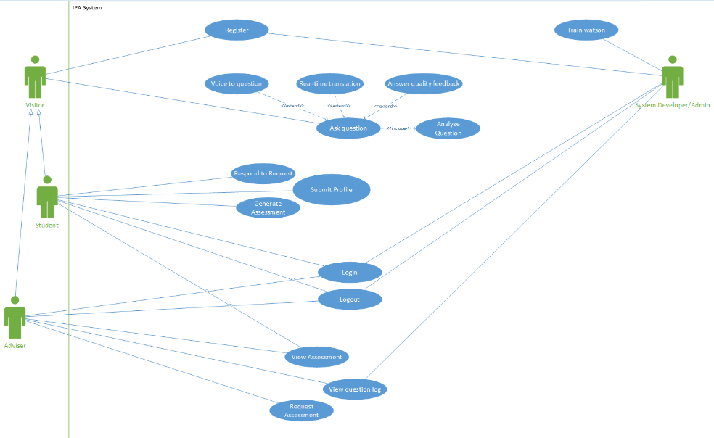

Figure : Use Case Diagram version 1 (subject to change)

#### User Scenarios

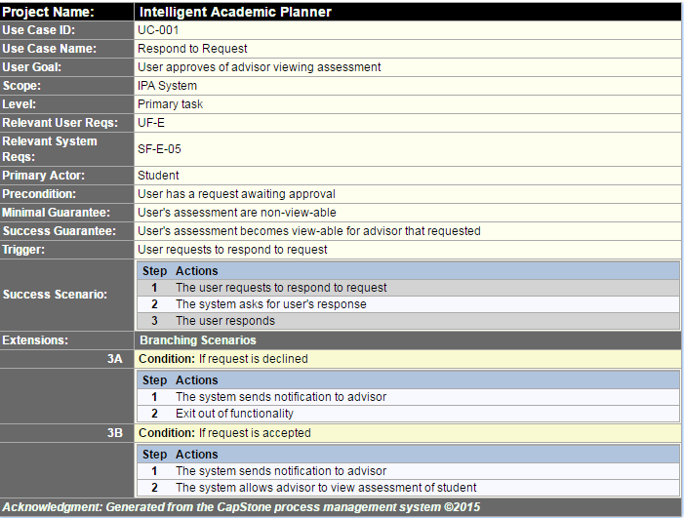

Figure : Description of Use Case "Respond to Request", which is related to requirements UF-E and SF-E-05

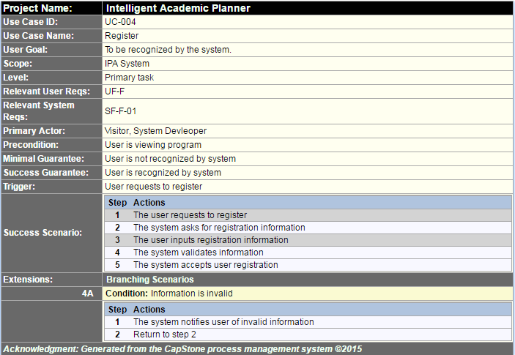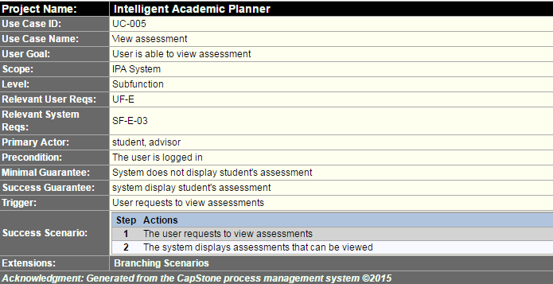

Figure : Description of Use Case "Register", which is related to requirements UF-F and SF-F-01

Figure : Description of Use Case "View Assessment", which is related to requirements UF-E and SF-E-03

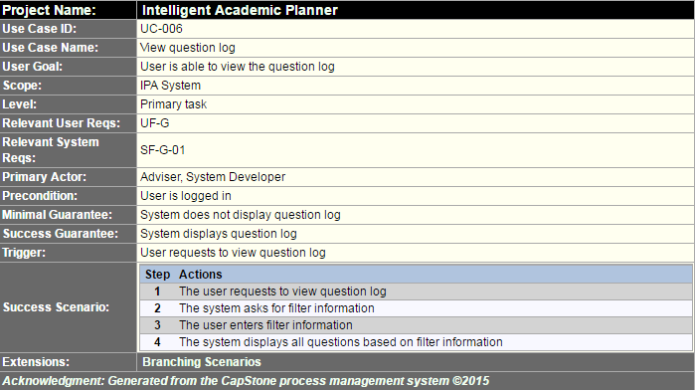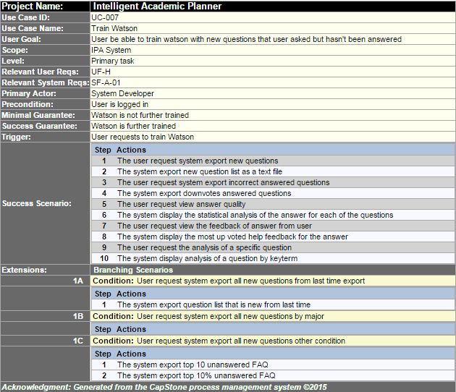

Figure : Description of Use Case "View Question Log", which is related to requirements UF-G and SF-G-01

Figure : Description of Use Case "Train Watson", which is related to requirements UF-H and SF-A-01

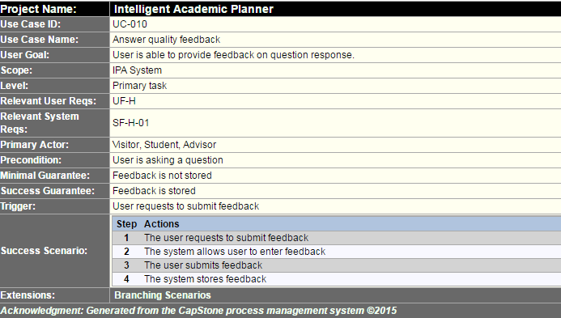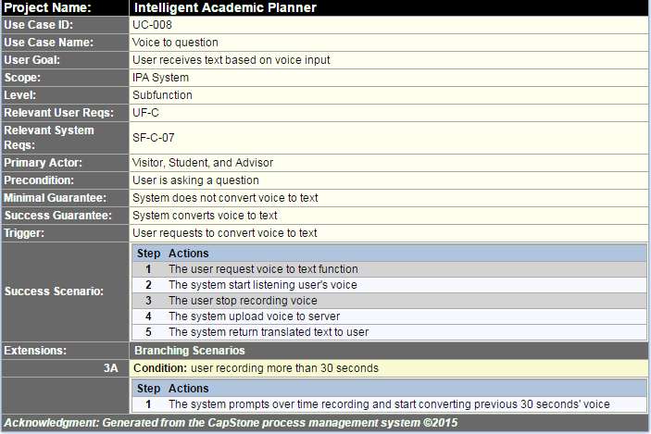

Figure : Description of Use Case "Answer Quality Feedback", which is related to requirements UF-H and SF-H-01

Figure : Description of Use Case "Voice To Question", which is related to requirements UF-C and SF-C-07

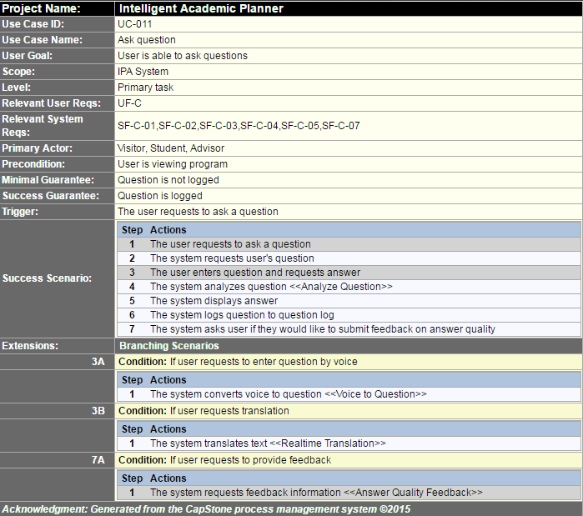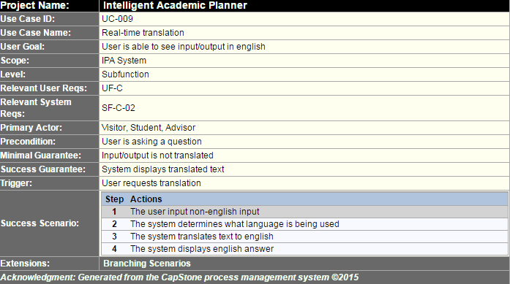

Figure : Description of Use Case "Ask Question", which is related to requirements UF-C, SF-C-01, SF-C-02, SF-C-03, SF-C-04, SF-C-05, and SF-C-07

Figure : Description of Use Case "Real-time Translation", which is related to requirements UF-C and SF-C-02

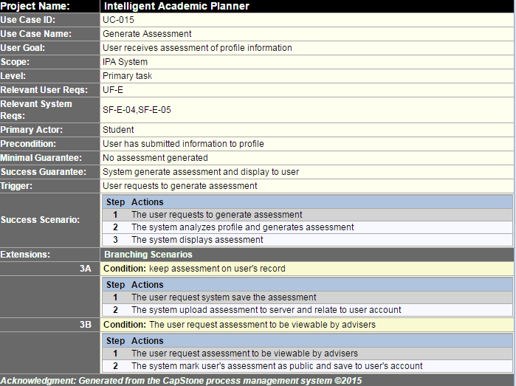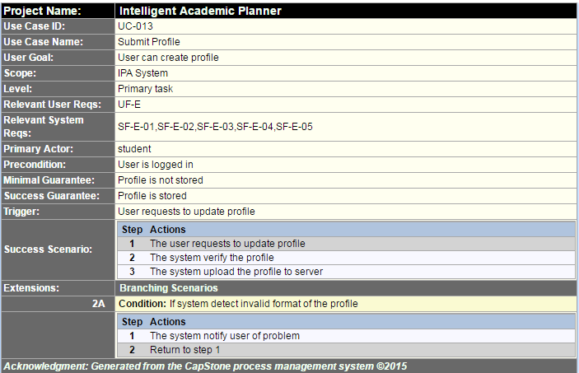

Figure : Description of Use Case "Generate Assessment", which is related to requirements UF-E, SF-E-04, and SF-E-05

Figure : Description of Use Case "Submit Profile", which is related to requirements UF-E, SF-E-01, SF-E-02, SF-E-03, SF-E-04, and SF-E-04

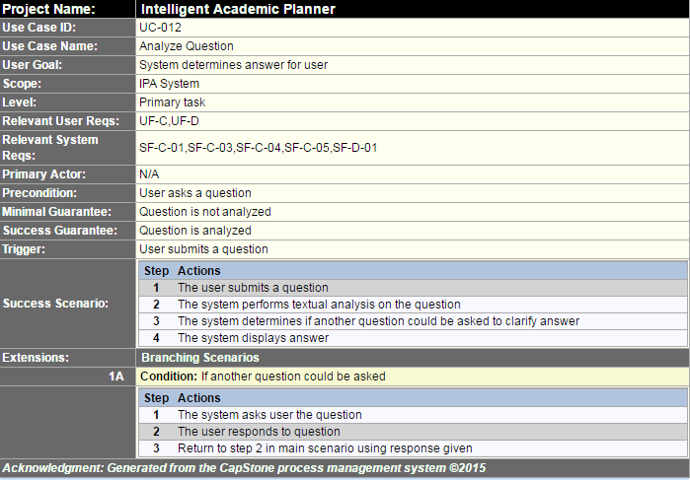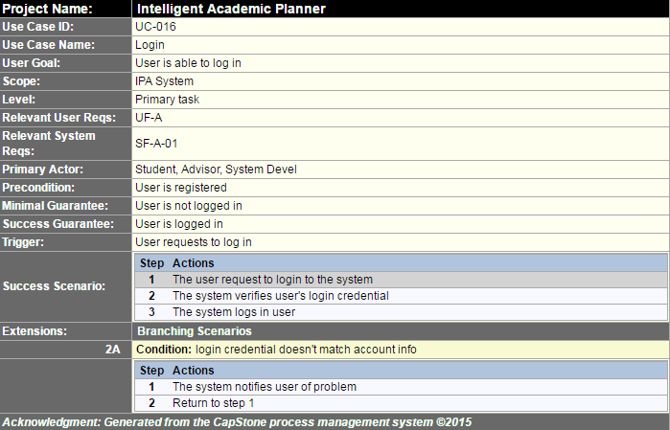

Figure : Description of Use Case "Analyze Question", which is related to requirements UF-C, UF-D, SF-C-01, SF-C-03, SF-C-04, SF-C-05, and SF-D-01

Figure : Description of Use Case "Login", which is related to requirements UF-A and SF-A-01

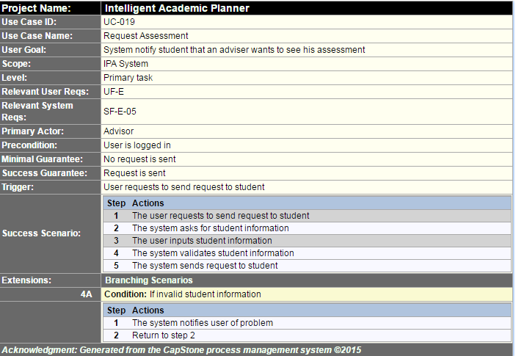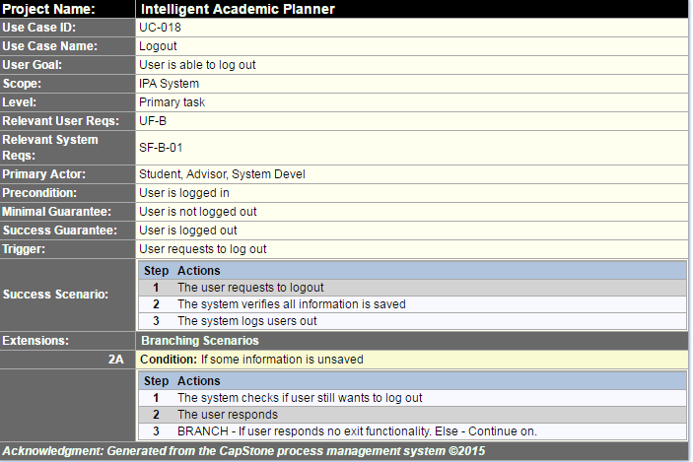

Figure : Description of Use Case "Request Assessment", which is related to requirements UF-E and SF-E-05

Figure : Description of Use Case "Logout", which is related to requirements UF-B and SF-B-01

#### List of User Functional Requirements

Figure : Description of user functional requirement UF-A, which is related to requirements SF-A-01 and use cases UC-016

Figure : Description of user functional requirement UF-B, which is related to requirements SF-B-01 and use cases UC-018

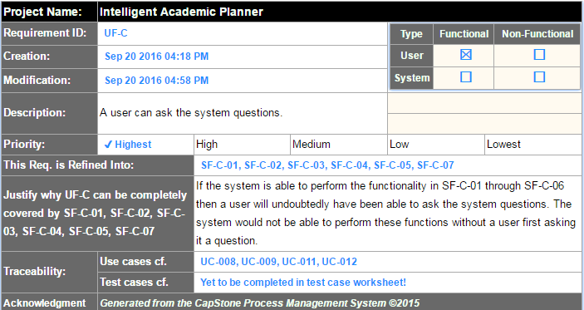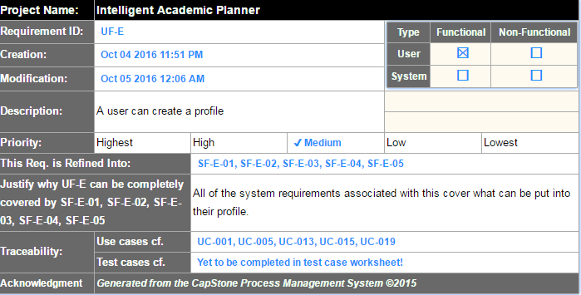

Figure : Description of user functional requirement UF-C which is related to requirements SF-C-01, SF-C-02, SF-C-03, SF-C-04, SF-C-04, SF-C-05, and SF-C-07 and use cases UC-008, UC-009, UC-011, and UC-012

Figure : Description of user functional requirement UF-E which is related to requirements SF-E-01, SF-E-02, SF-E-03, SF-E-04, and SF-E-05 and use cases UC-001, UC-005, UC-013, UC-015, and UC-019

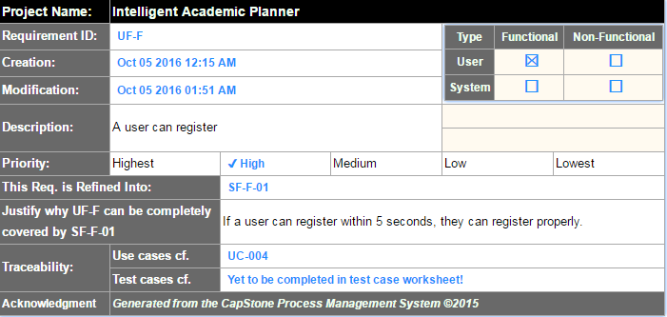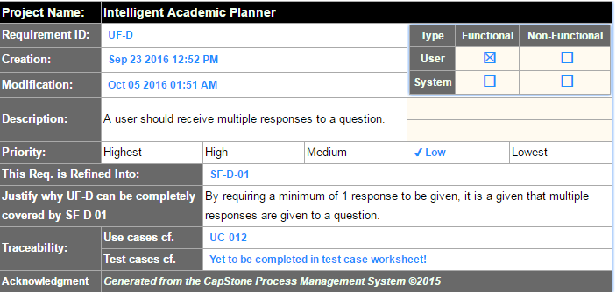

Figure : Description of user functional requirement UF-F which is related to requirements SF-F-01 and use cases UC-004

Figure : Description of user functional requirement UF-D which is related to requirements SF-D-01 and use cases UC-012

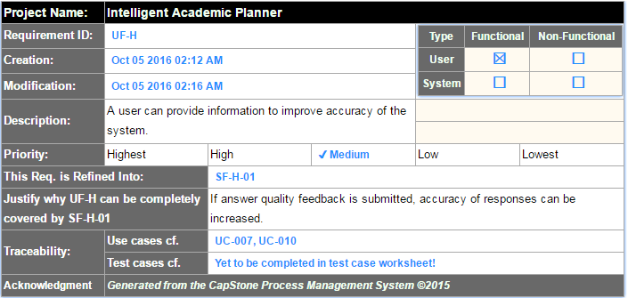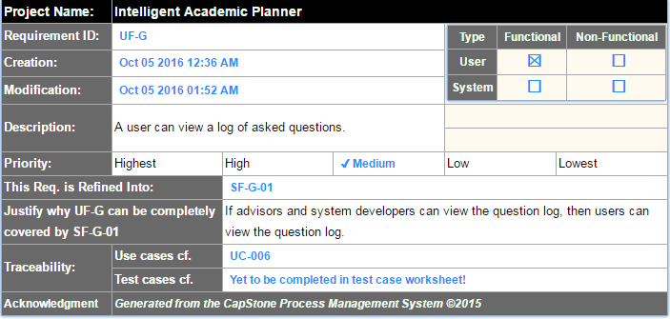

Figure : Description of user functional requirement UF-H, which is related to requirements SF-H-01 and use cases UC-007 and UC-010

Figure : Description of user functional requirement UF-G, which is related to requirements SF-G-01 and use cases UC-006

### 4.1.4. Non-functional Requirements

#### 4.1.4.1. Product: Performance Requirements

Figure : Description of user non-functional performance requirement UP-03 which is related to requirement SP-03-01

#### 4.1.4.2. Product: Dependability/Reliability/Security

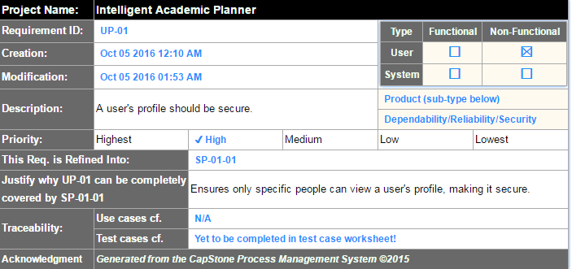

Figure : Description of user non-functional security requirement UP-01, which is related to requirement SP-01-01

#### 4.1.4.3. Organizational: Development Requirements

Figure : Description of user non-functional developmental requirement UO-01, which is related to requirement SO-01-01

# System Requirements

## Functional Requirements

### List of System Functional Requirements

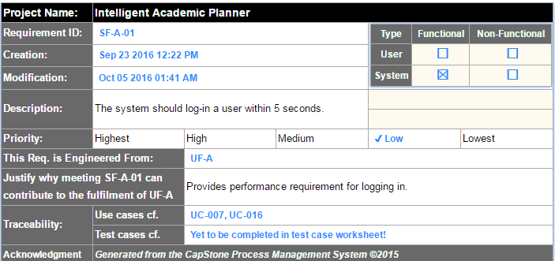

Figure : Description of system functional requirement SF-A-01 which is related to requirements UF-A and use cases UC-007 and UC-016

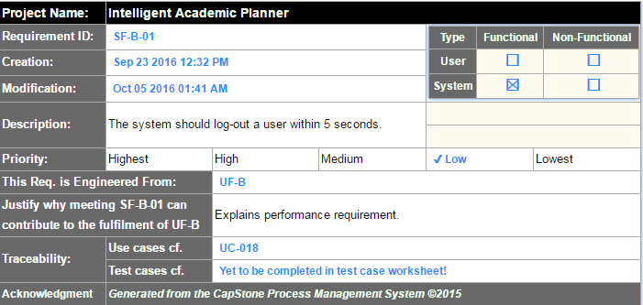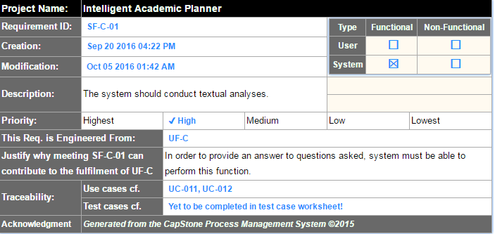

Figure : Description of system functional requirement SF-B-01, which is related to requirements UF-B and use cases UC-018

Figure : Description of system functional requirement SF-C-01, which is related to requirements UF-C and use cases UC-011 and UC-012

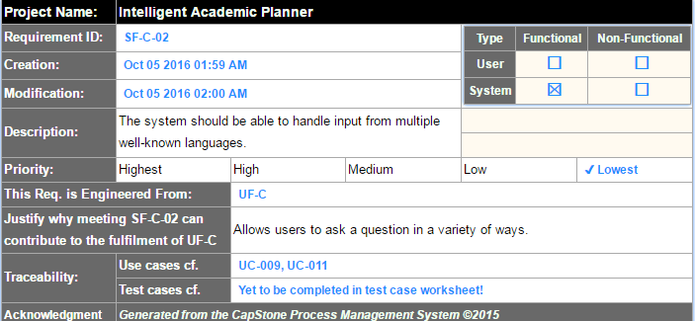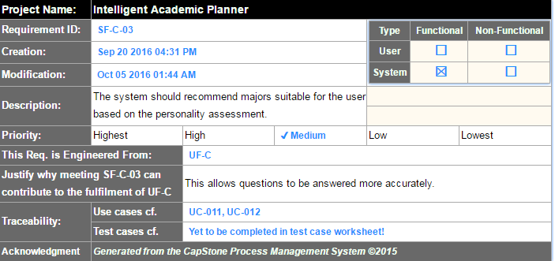

Figure : Description of system functional requirement SF-C-02, which is related to requirements UF-C and use cases UC-009 and UC-011

Figure : Description of system functional requirement SF-C-03, which is related to requirements UF-C and use cases UC-011 and UC-012

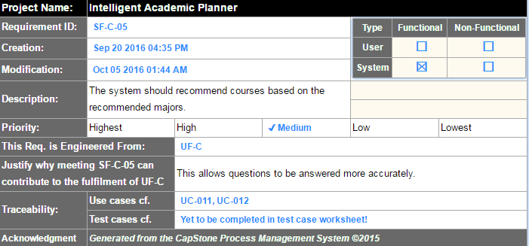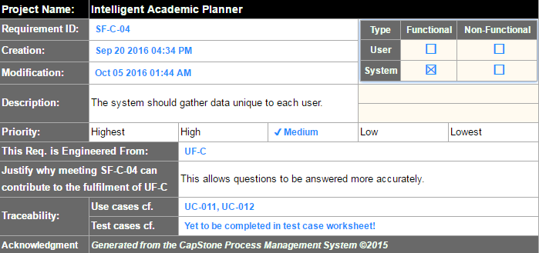

Figure : Description of system functional requirement SF-C-05, which is related to requirements UF-C and use cases UC-011 and UC-012

Figure : Description of system functional requirement SF-C-04 which is related to requirements UF-C and use cases UC-011 and UC-012

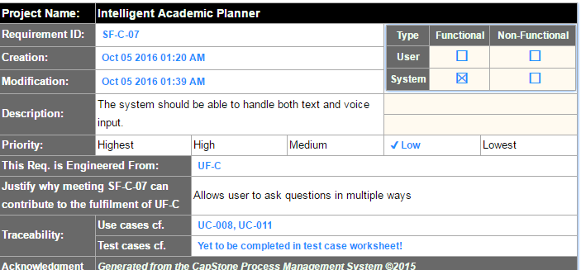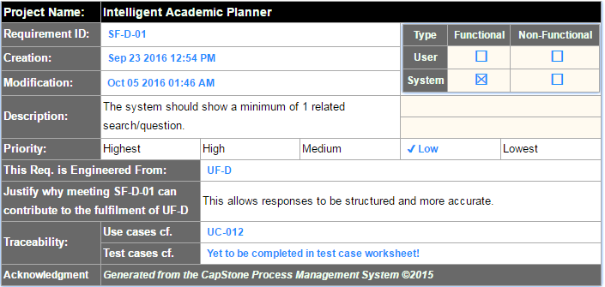

Figure : Description of system functional requirement SF-C-07 which is related to requirements UF-C and use cases UC-008 and UC-011

Figure : Description of system functional requirement SF-D-01, which is related to requirements UF-D and use cases UC-012

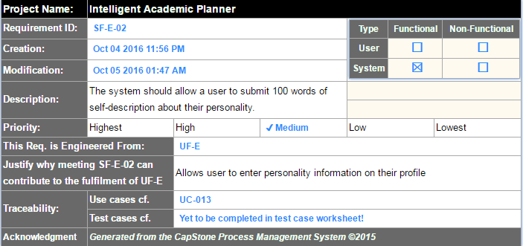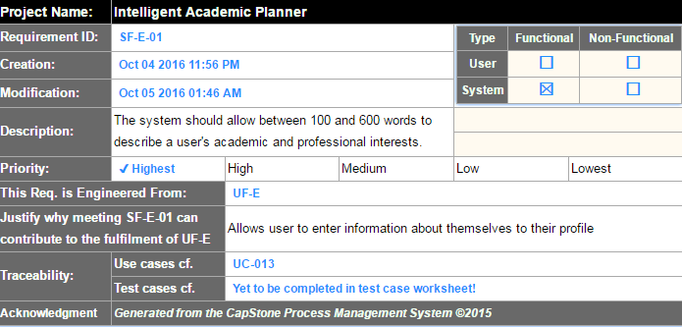

Figure : Description of system functional requirements SF-E-02, which is related to requirements UF-E and use cases UC-013

Figure : Description of system functional requirement SF-E-01, which is related to requirements UF-E and use cases UC-013

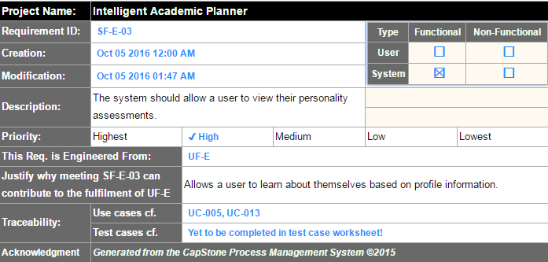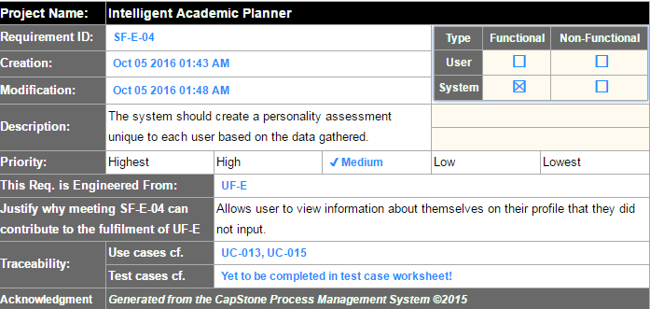

Figure : Description of system functional requirement SF-E-03, which is related to requirements UF-E and use cases UC-005 and UC-013

Figure : Description of system functional requirement SF-E-04, which is related to requirements UF-E and use cases UC-013 and UC-015

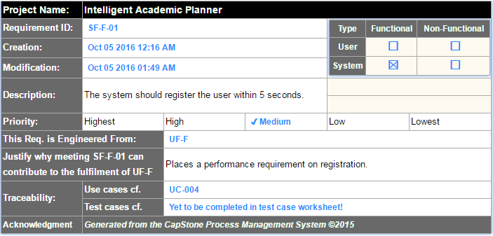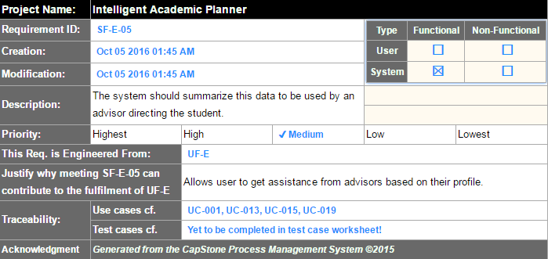

Figure : Description of system functional requirement SF-F-01, which is related to requirements UF-F and use cases UC-004

Figure : Description of system functional requirement SF-E-05, which is related to requirements UF-E and use cases UC-001, UC-013, UC-015, and UC-019

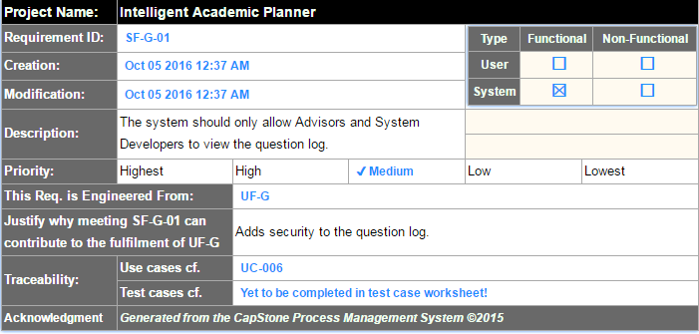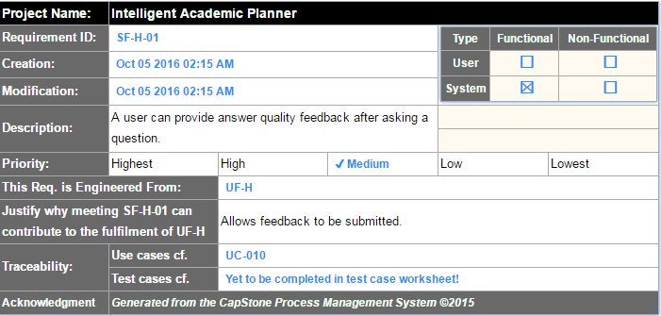

Figure : Description of system functional requirement SF-G-01, which is related to requirement UF-G and use cases UC-006

Figure : Description of system functional requirement SF-H-01, which is related to requirements UF-H and use cases UC-010

#### System Behavior

Figure : Sequence diagram for "Voice to Question", related to UC-008

Figure : Sequence diagram for "View Question Log", related to UC-006

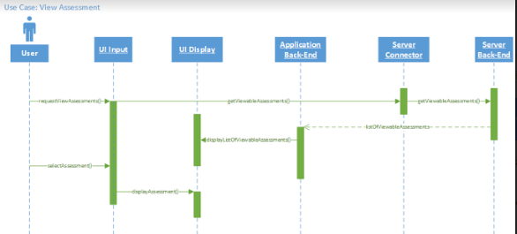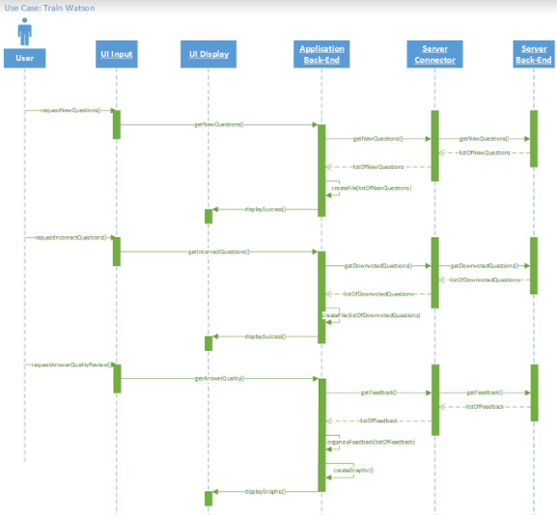

Figure : Sequence diagram for "View Assessment", related to UC-005

Figure : Sequence diagram for "Train Watson", related to UC-007

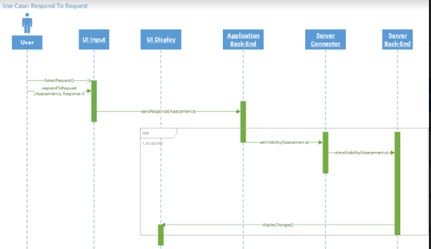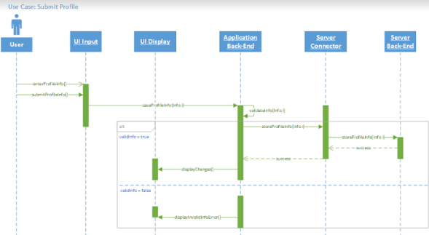

Figure : Sequence diagram for "Respond to Request", related to UC-001

Figure : Sequence diagram for "Submit Profile", related to UC-013

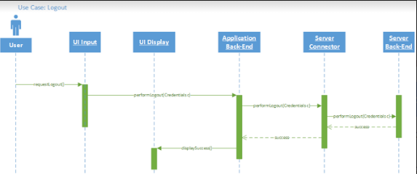

Figure : Sequence diagram for "Logout", related to UC-018

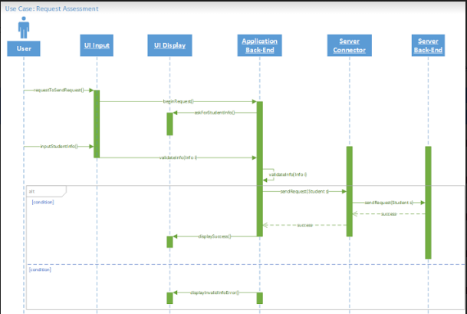

Figure : Sequence Diagram for "Request Assessment", related to UC-019

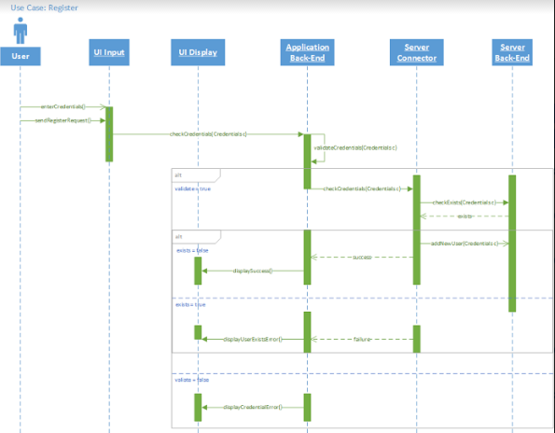

Figure : Sequence diagram for "Register", related to UC-004

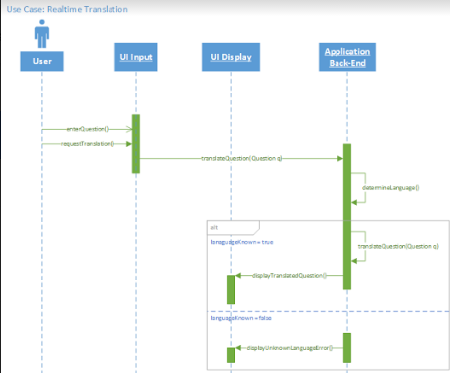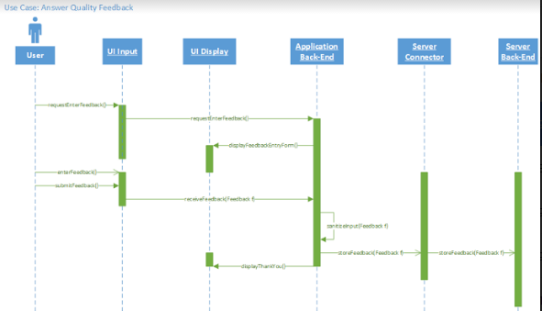

Figure : Sequence diagram for "Answer Quality Feedback", related to UC-010

Figure : Sequence diagram for "Real-time Translation", related to UC-009

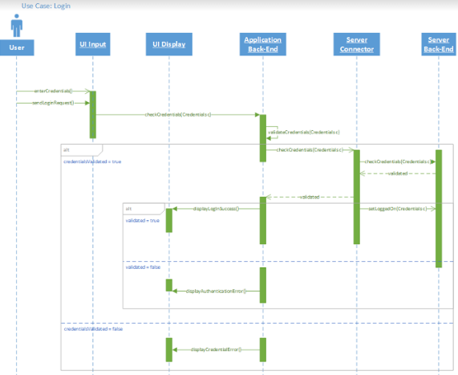

Figure : Sequence diagram for "Login", related to UC-016

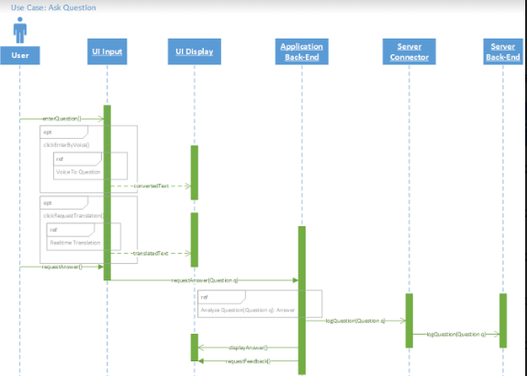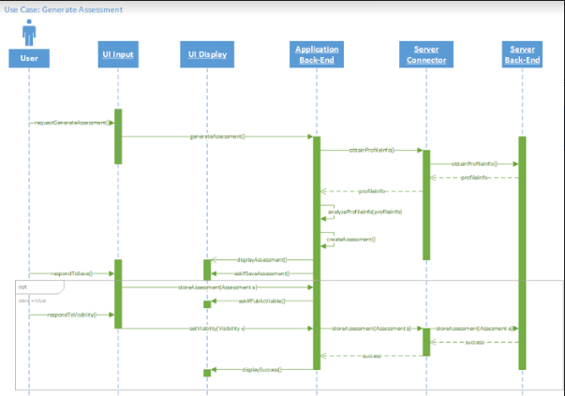

Figure : Sequence diagram for "Ask Question", related to UC-011

Figure : Sequence diagram for "Generate Assessment", related to UC-015

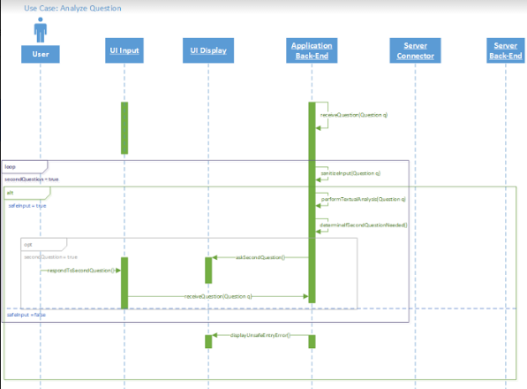

Figure : Sequence diagram for "Analyze Question", related to UC-012

#### Data Requirements

**UC001 - Input: User whose assessment is being requested.**

**UC004 - Input: User email address and real name for registration and login.**

**UC004 - Input: User password for registration and login.**

**UC006 - Input: Filter information for useful question log (eg. major, minor, courses).**

**UC007 - Output: List of newly generated questions exported to a text file.**

**UC007 - Output: List of unanswered frequently asked questions.**

**UC008 - Input: Questions submitted in the form of voice recordings.**

**UC008 - Output: The voice recording is converted to text and displayed to the user.**

**UC009 - Input: Untranslated text.**

**UC009 - Output: Translated text.**

**UC010 - Input: User feedback pertaining to the relevance of the responses to their questions.**

**UC011 - Input: User questions.**

**UC011 - Output: Responses to user questions.**

**UC013 - Input: User profile.**

**UC015 - Output: User assessment based on their profile and search history.**

**UC019 - Input: The advisor who is requesting the student’s assessment.**

### 4.2.2. Non-functional Requirements

#### 4.2.2.1. Product: Performance Requirements

Figure : Description of system non-functional performance requirement SP-03-01, related to requirement UP-03

#### 4.2.2.2. Product: Dependability/Reliability/Security

Figure : Description of system non-functional security requirement SP-01-01, which is related to requirement UP-01

#### 4.2.2.3. Organizational: Development Requirements

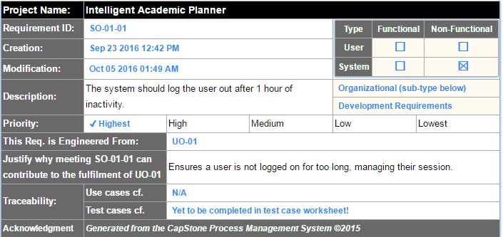

Figure : Description of system non-functional development requirement SO-01-01, which is related to requirement UO-01

# Requirements Trace Table

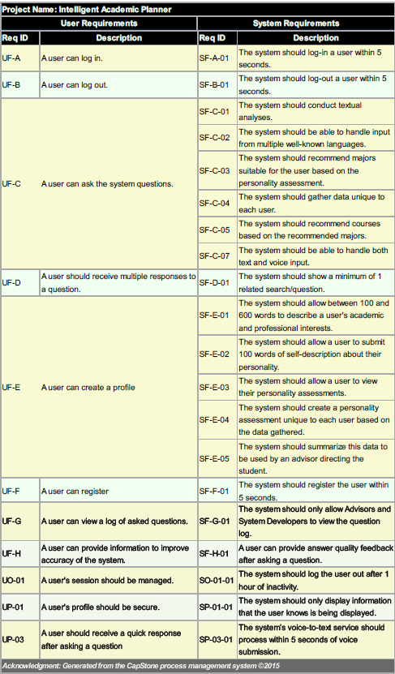

Figure : Overall view of all user and system requirements

# Exploratory Studies

## Relevant Techniques

**Surveys**

## Relevant Packages/Products

**N/A**

## Broader Impacts

**This project can be expanded to include other majors within Behrend or branches of Penn State University. On a grand scale, this type of tool would be a beneficial tool for high school juniors and seniors, as well as college freshman.**

# System Design

## Architectural Design

**Layered Architecture**

# System Implementation

## Programming Languages & Tools

**Bluemix (conversation, retrieve and rank, alchemyAPI,…)**

**MongoDB**

**Node.js**

## Coding Conventions

**N/A**

## Code Version Control

**GitHub**

# Challenges & Open Issues

## Challenges Faced in Requirements Engineering

* + 1. **Initially, we struggled to determine the scope of the project. Watson has many features, therefore we had to be very specific about which of these features would make the most sense for our project’s initial development.**
    2. **Understanding the domain, or what sort of questions we wanted Watson to answer.**
    3. **Be able to benchmark the accuracy of answering system.**
    4. **Be able to automate the training/learning system.**

# System Manuals

## Instructions for System Development

### How to setup the development environment

* + - 1. **The Intelligent Academic Planner project is a web application, that will be accessible publicly on Heroku, a Node.JS environment host platform. The source code will be stored by GitHub, for version control purposes. And the master version will always be automatically deployed and run on Heroku. There is no restriction on what IDE will be used by each group member.**

### Notes on system further extension

* + - 1. **Automate question and feedback log DB**
      2. **Natural language extension**
      3. **Analytical library**
      4. **Visual recognition on building**
      5. **Attitude analysis on question**
      6. **Campus direction utility**
      7. **Course info helper (location, material, etc…)**
      8. **News/feeds utility**

# 12. References

* I. B. M. What is IBM Watson? http://www.ibm.com/watson/what-is-watson.html (accessed Oct 5, 2016).
* MonkeyLearn http://docs.monkeylearn.com/ (accessed Oct 5, 2016).
* AlchemyAPI http://www.alchemyapi.com/ (accessed Oct 5, 2016).
* Watson Developer Cloud https://www.ibm.com/watson/developercloud/retrieve-rank.html (accessed Oct 5, 2016).
* Watson Developer Cloud https://www.ibm.com/watson/developercloud/conversation.html (accessed Oct 5, 2016).
* Watson Developer Cloud <https://www.ibm.com/watson/developercloud/speech-to-text.html> (accessed Oct 5, 2016).
* Watson Developer Cloud <https://www.ibm.com/watson/developercloud/visual-recognition.html> (accessed Oct 5, 2016).